Write a code using Terraform that deploys and achieves the following:-

Create an EC2 Instance on AWS Cloud using the below-mentioned ubuntu AMI and instance_type. Or, (You can use of your choice as well) ami = "ami-0461b1436c9b3c1a3" instance_type = "t2.micro

Terraform EC2 Instance Creation on AWS
We will create:
- AWS EC2 Instance
- Using Terraform
- Ubuntu AMI
- t2.micro instance type
Step 1: Install Required Tools
1. Install Terraform
Download from:
Terraform Official Website
Verify:
terraform -version

2. Install AWS CLI
Download:
AWS CLI Download
Verify:
aws --version

Step 2: Create AWS Account
Go to:
AWS Console
Create free-tier account.

Step 3: Create IAM User for Terraform
AWS Console Steps
Go to:
- IAM
- Users
- Create User
Example:
terraform-user
Attach policy:
AdministratorAccess
Create Access Key:
- Access Key ID
- Secret Access Key
Save them safely.

Step 4: Configure AWS CLI
Run:
aws configure
Enter:
AWS Access Key ID
AWS Secret Access Key
Region name = us-east-1
Output format = json
Example:
aws configure
AWS Access Key ID [None]: AKIAxxxx
AWS Secret Access Key [None]: xxxxx
Default region name [None]: us-east-1
Default output format [None]: json
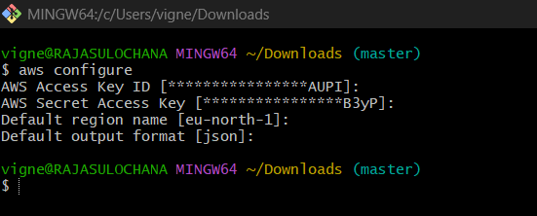

Step 5: Create Project Folder
mkdir terraform-ec2-project
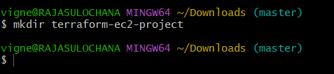
Go inside:
cd terraform-ec2-project
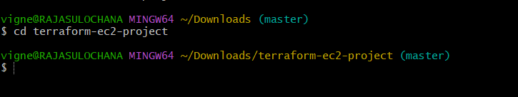

Step 6: Create Terraform File
Create file:
vi main.tf
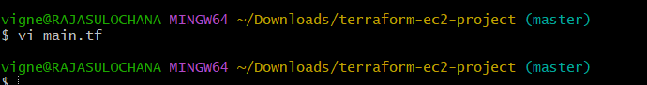

Step 7: Write Terraform Code
Paste this code into main.tf
provider "aws" {
region = "eu-north-1"
}
resource "aws_instance" "my_ec2" {
ami = "ami-05d62b9bc5a6ca605"
instance_type = "t3.micro"
tags = {
Name = "Terraform-EC2"
}
}

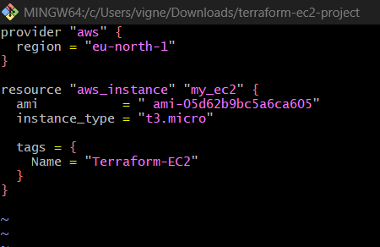

Step 8: Initialize Terraform
Run:
terraform init
What it does:
- Downloads AWS provider plugins
- Initializes Terraform project
Expected:
Terraform has been successfully initialized!
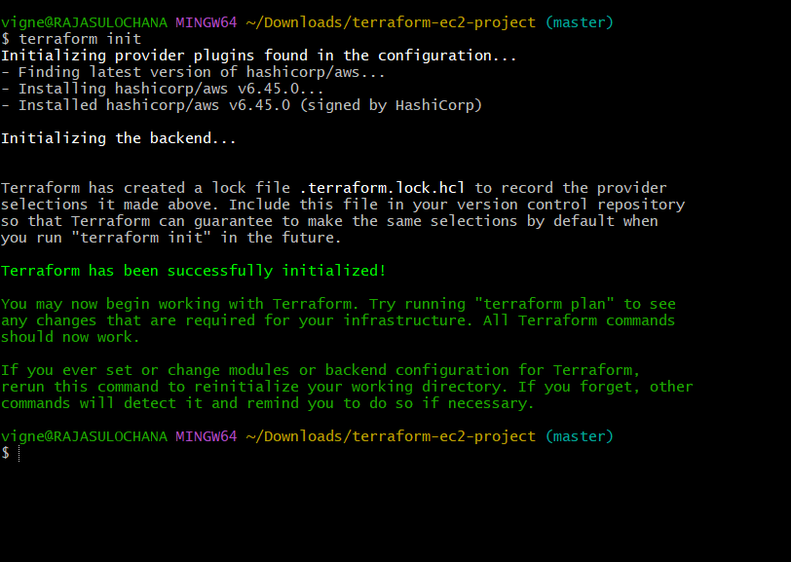

Step 9: Validate Configuration
Run:
terraform validate
Expected:
Success! The configuration is valid.
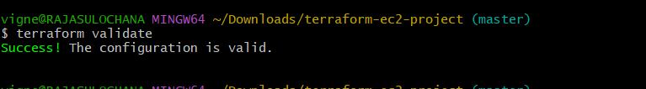

Step 10: Check Execution Plan
Run:
terraform plan
What it does:
- Shows what Terraform will create
- No resources created yet
Expected:
Plan: 1 to add, 0 to change, 0 to destroy.
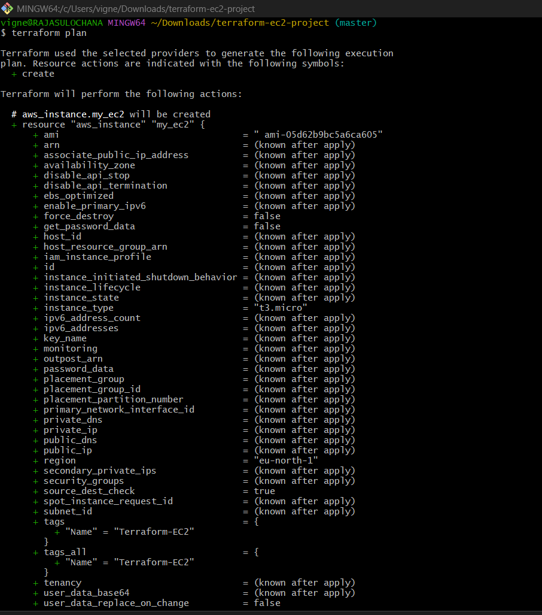
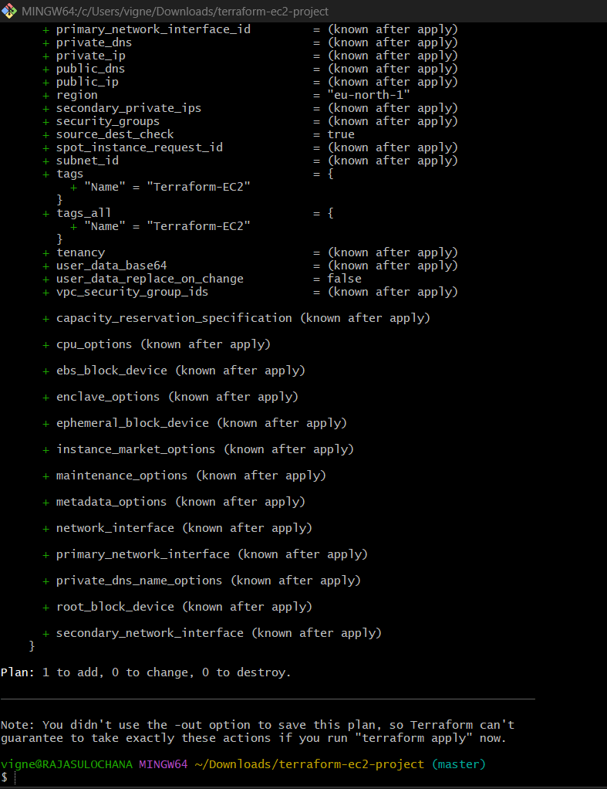

Step 11: Create EC2 Instance
Run:
terraform apply
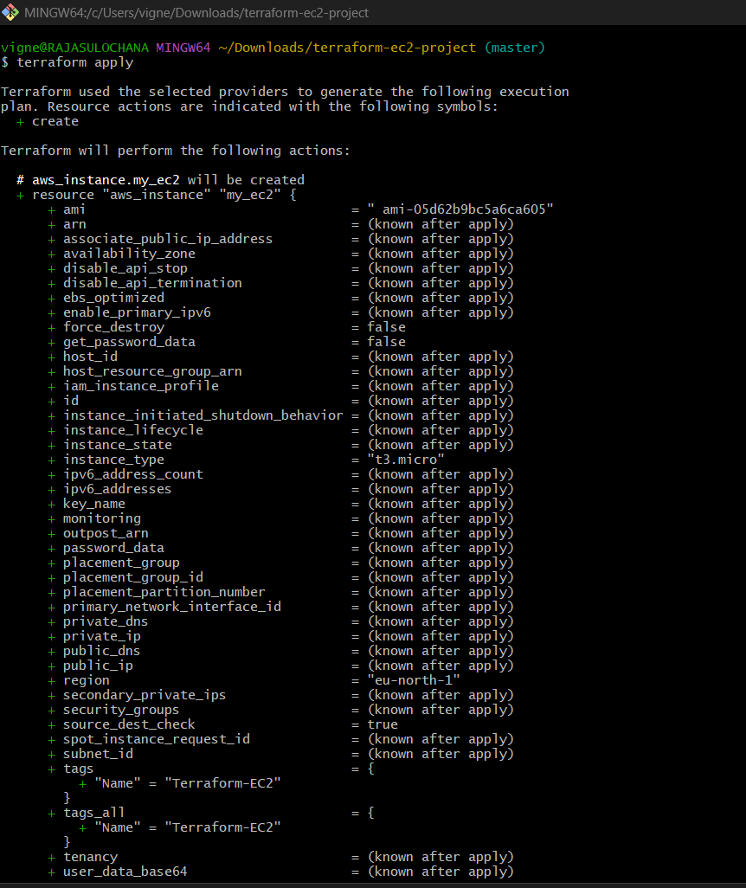
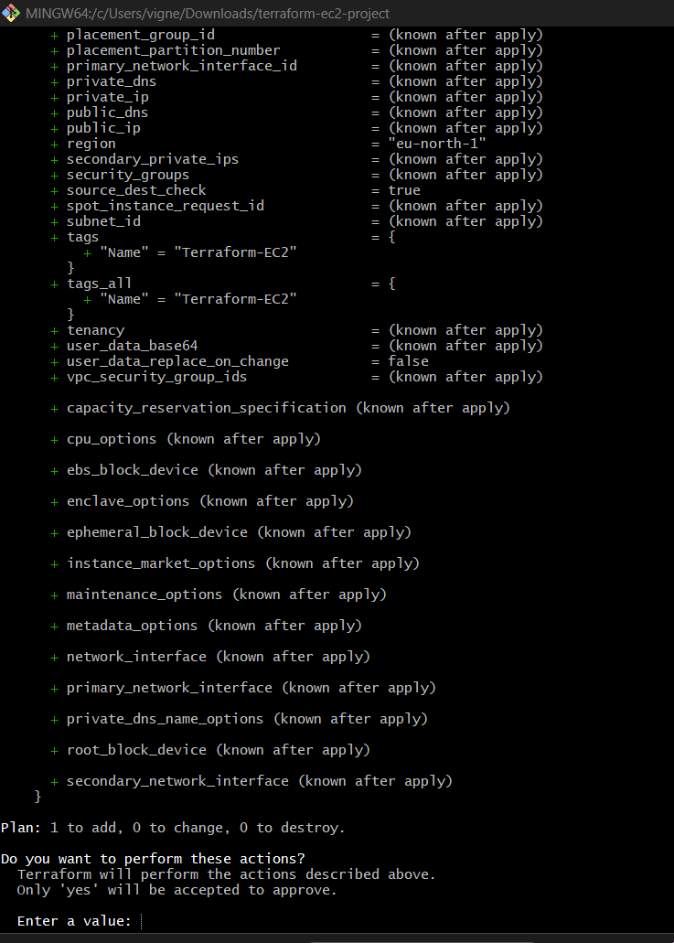
Type:
yes

Terraform will:
- Connect AWS
- Create EC2 instance
Expected:
Apply complete! Resources: 1 added.
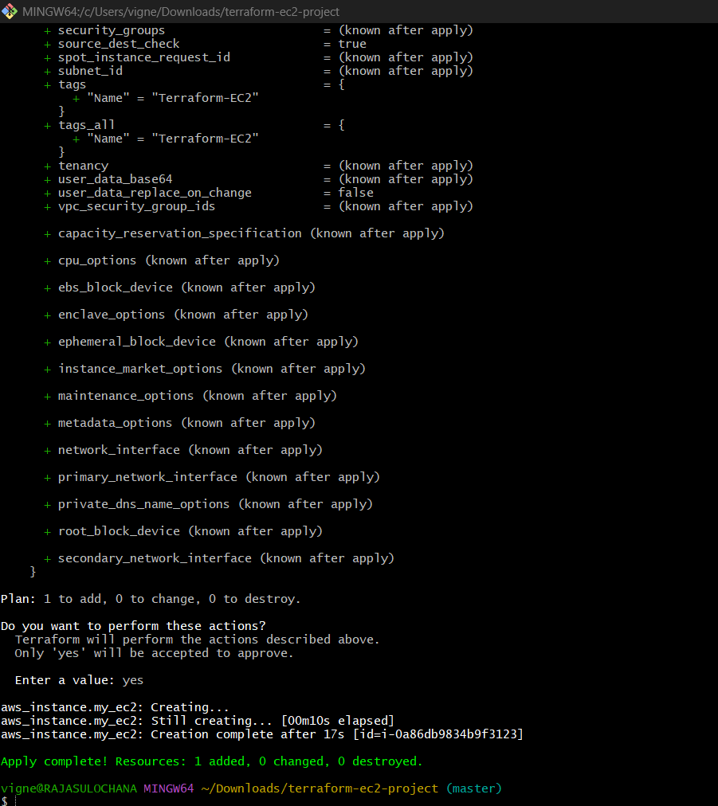

Step 12: Verify EC2 Instance
Go to AWS Console:
- EC2 Dashboard
- Instances
You will see:
Terraform-EC2
running.
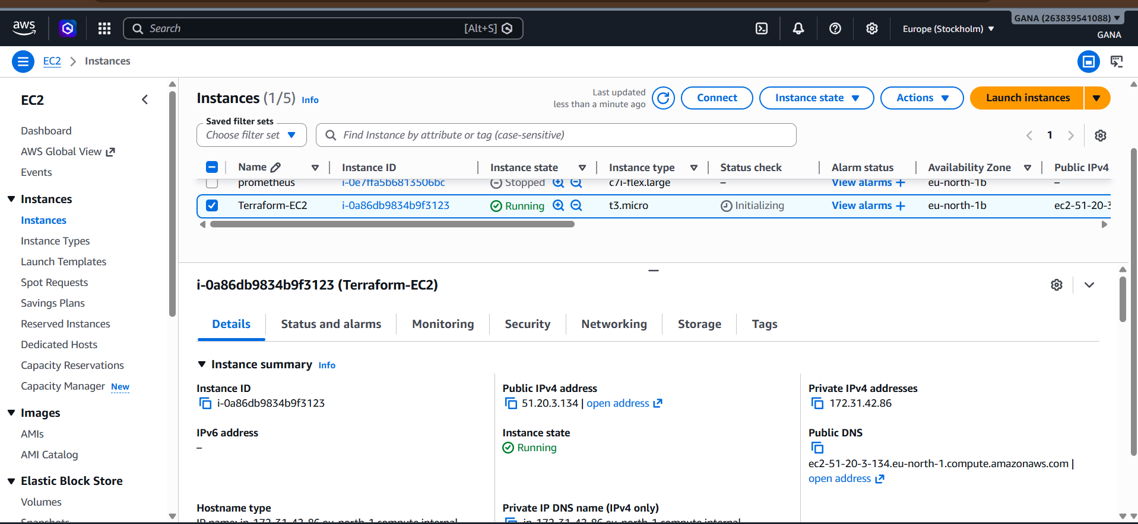

Step 13: Destroy Resources (Important)
To avoid AWS charges:
terraform destroy
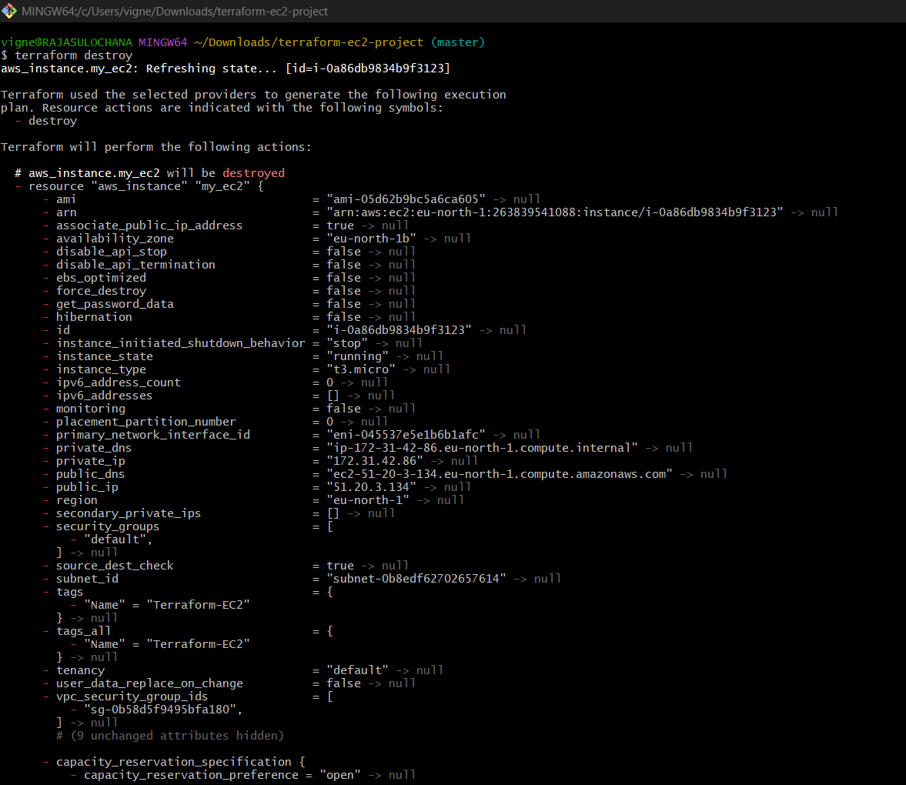

Type:
yes
Expected:
Destroy complete!
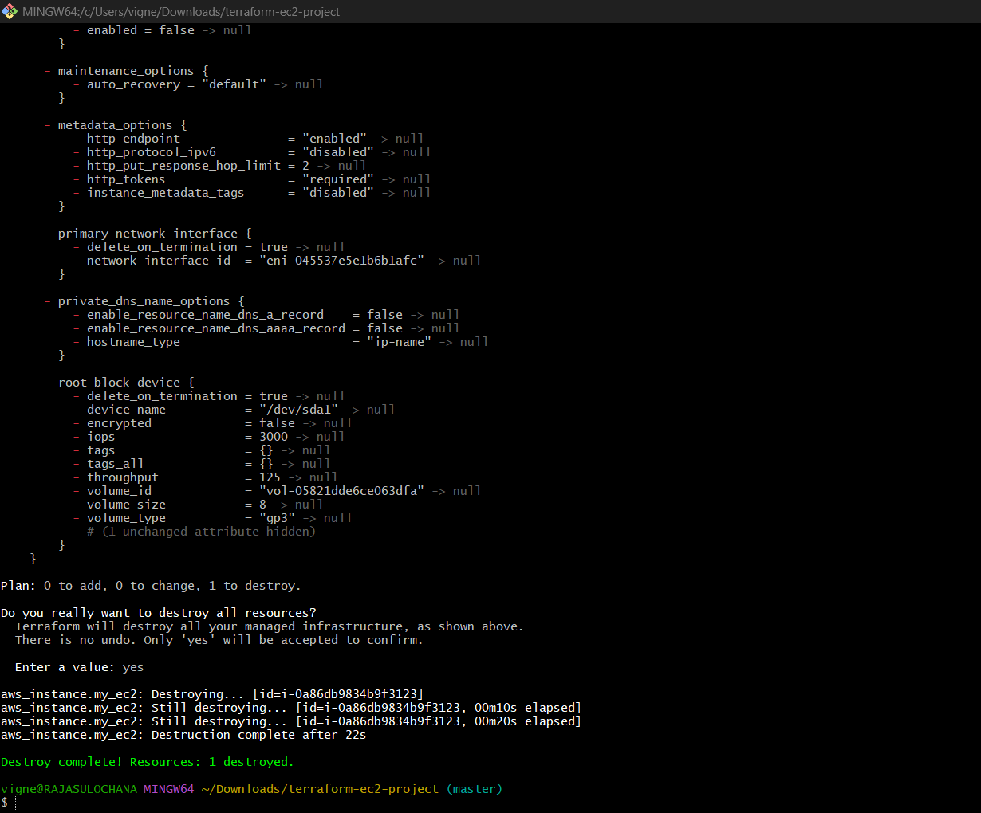

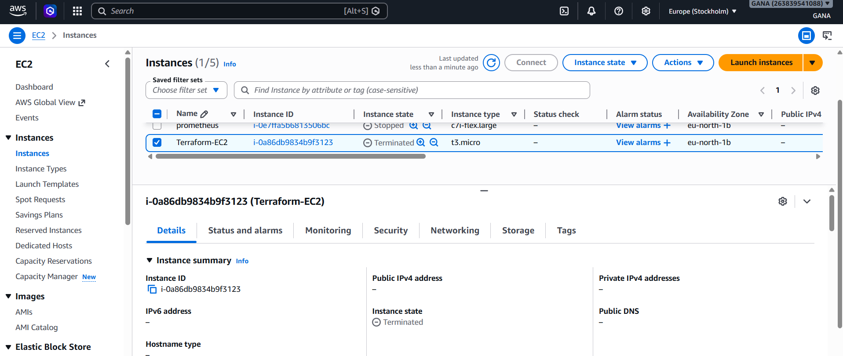

Complete Project Structure
terraform-ec2-project/
│
├── main.tf
├── terraform.tfstate
├── terraform.tfstate.backup
└── .terraform/

Understanding the Code
Provider Block
provider "aws" {
region = "us-east-1"
}
Purpose:
- Connects Terraform to AWS

Resource Block
resource "aws_instance" "my_ec2"
Purpose:
- Creates EC2 instance

AMI
ami = "ami-0461b1436c9b3c1a3"
Purpose:
- Ubuntu operating system image

Instance Type
instance_type = "t2.micro"
Purpose:
- Free-tier EC2 machine size

Tags
tags = {
Name = "Terraform-EC2"
}
Purpose:
- Gives name to EC2 instance

Important Terraform Commands
Command | Purpose
terraform init | Initialize project
terraform validate | Validate syntax
terraform plan | Preview changes
terraform apply | Create resources
terraform destroy | Delete resources
terraform fmt | Format code
terraform show | Show state details

2) Install Web Server on EC2 using Terraform (Port 8080)
We will now:
- Create EC2 Instance
- Install Apache Web Server automatically
- Change listening port to 8080
- Access website from browser

Architecture
Terraform
↓
AWS EC2
↓
Ubuntu Server
↓
Apache Installed
↓
Runs on Port 8080

Step 1: Create Project Folder
mkdir terraform-webserver
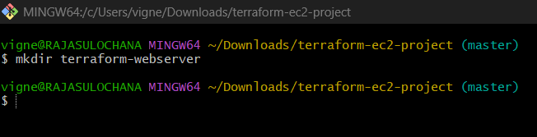
Go inside:
cd terraform-webserver

Step 2: Create Terraform File
Create:
vi main.tf
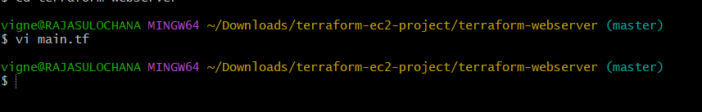

Step 3: Paste Complete Terraform Code

resource "aws_instance" "my_ec2" {
ami = "ami-05d62b9bc5a6ca605"
instance_type = "t2.micro"
security_groups = ["default"]
user_data = <<-EOF
#!/bin/bash
apt update -y
apt install apache2 -y
sed -i 's/80/8080/g' /etc/apache2/ports.conf
sed -i 's/:80/:8080/g' /etc/apache2/sites-enabled/000-default.conf
systemctl restart apache2
systemctl enable apache2
echo "<h1>Web Server Running on Port 8080</h1>" > /var/www/html/index.html
EOF
tags = {
Name = "Terraform-WebServer"
}
}
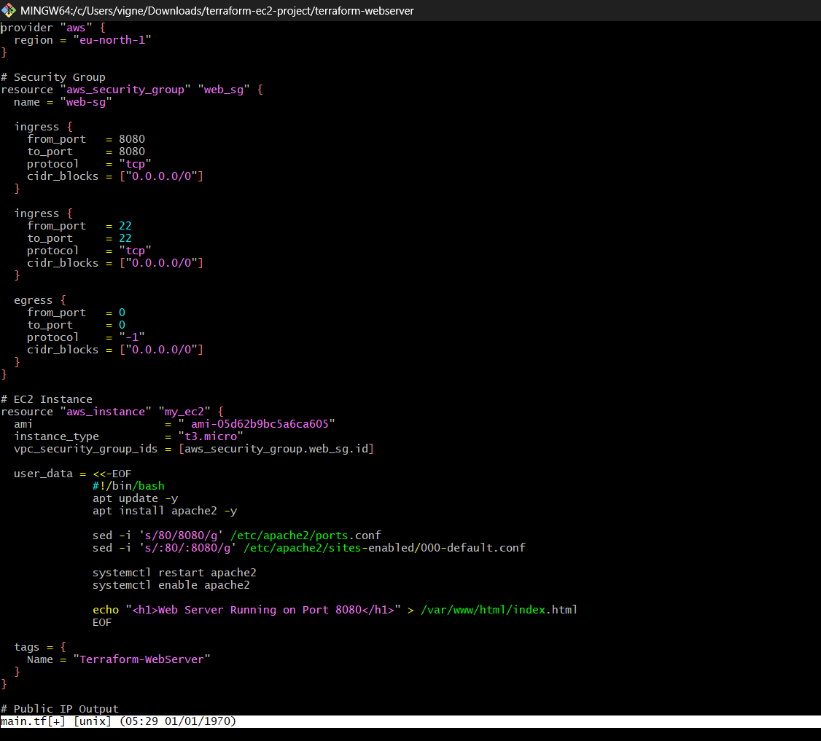
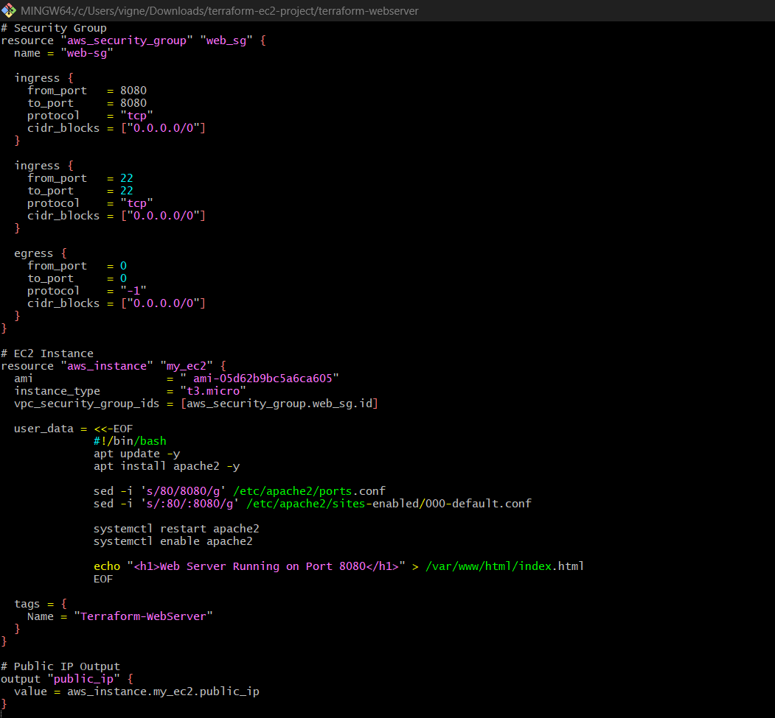

Step 4: Initialize Terraform
Run:
terraform init
Expected:
Terraform has been successfully initialized!
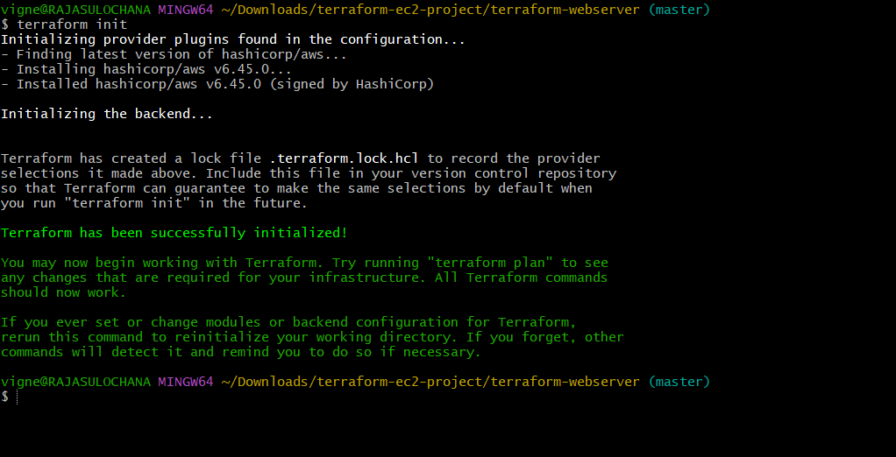

Step 5: Validate
terraform validate
Expected:
Success! The configuration is valid.
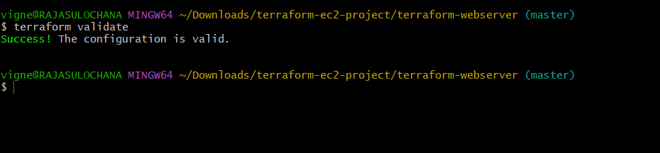

Step 6: Preview Changes
terraform plan
You will see:
1 EC2 instance
1 security group
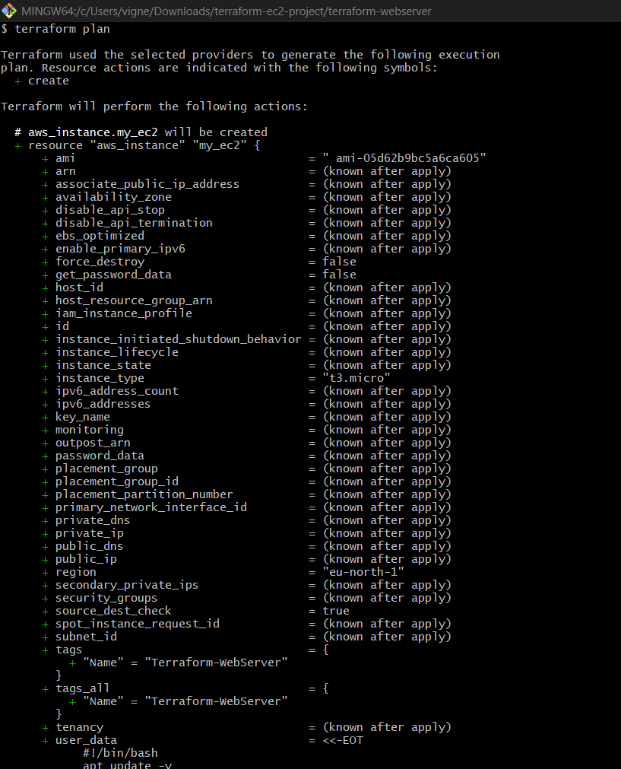
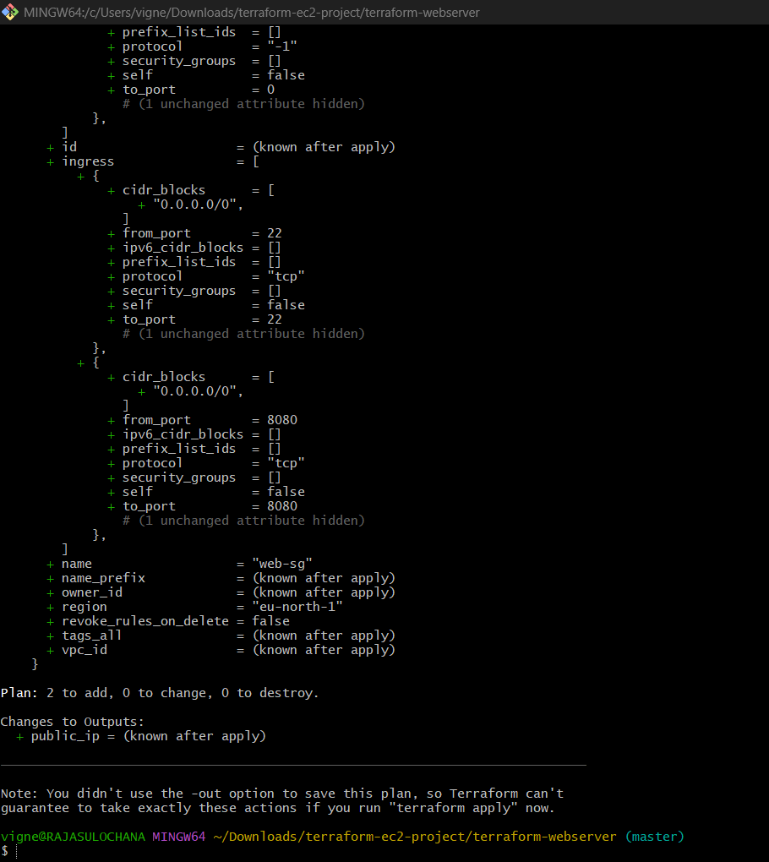

Step 7: Create Infrastructure
terraform apply
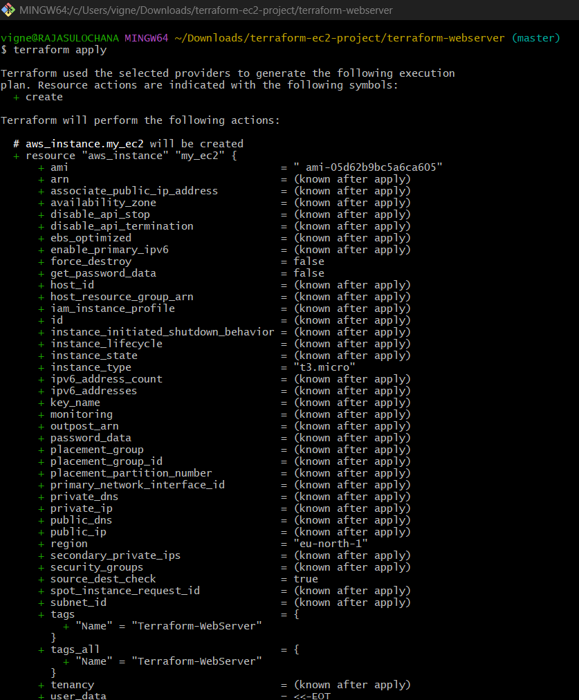

Type:
yes
Wait 1–2 minutes.
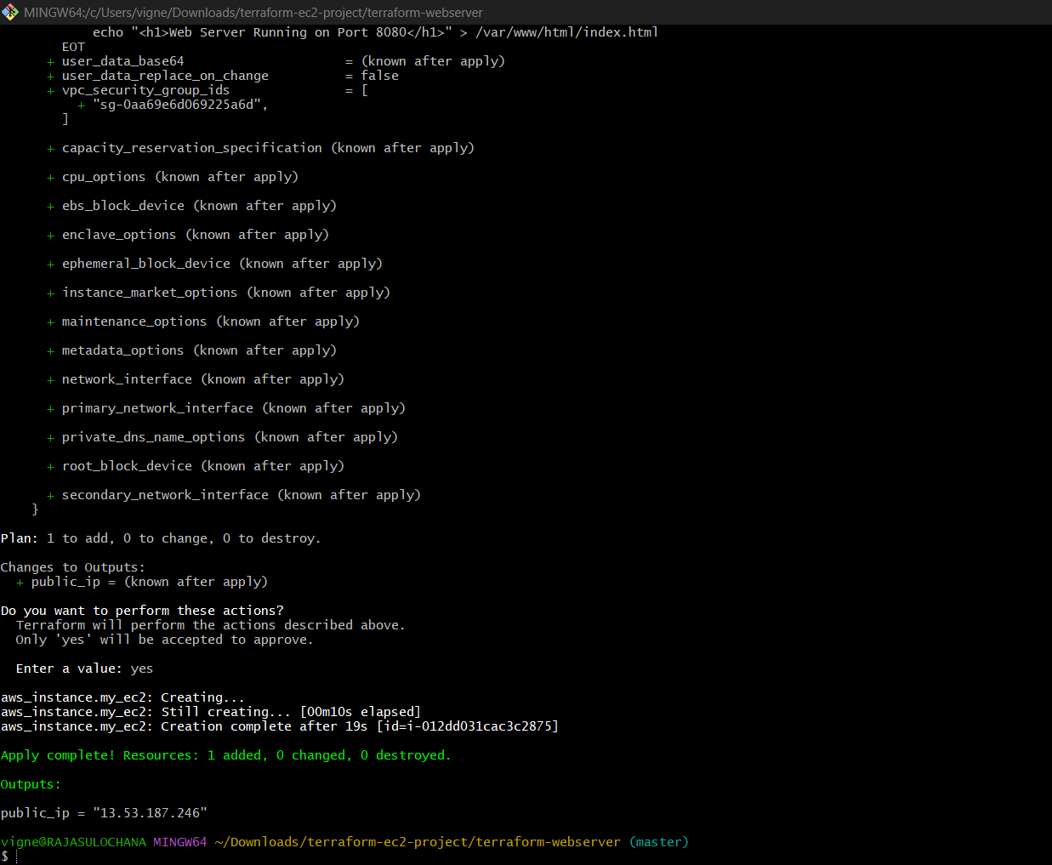

Step 8: Get Public IP
Terraform output:
Outputs:
public_ip = "54.xx.xx.xx"
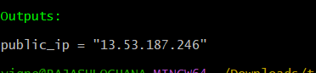
13.53.187.246

Step 9: Access Website
Open browser:
http://PUBLIC-IP:8080
Example:
http://13.53.187.246:8080/

Expected Output
Web Server Running on Port 8080
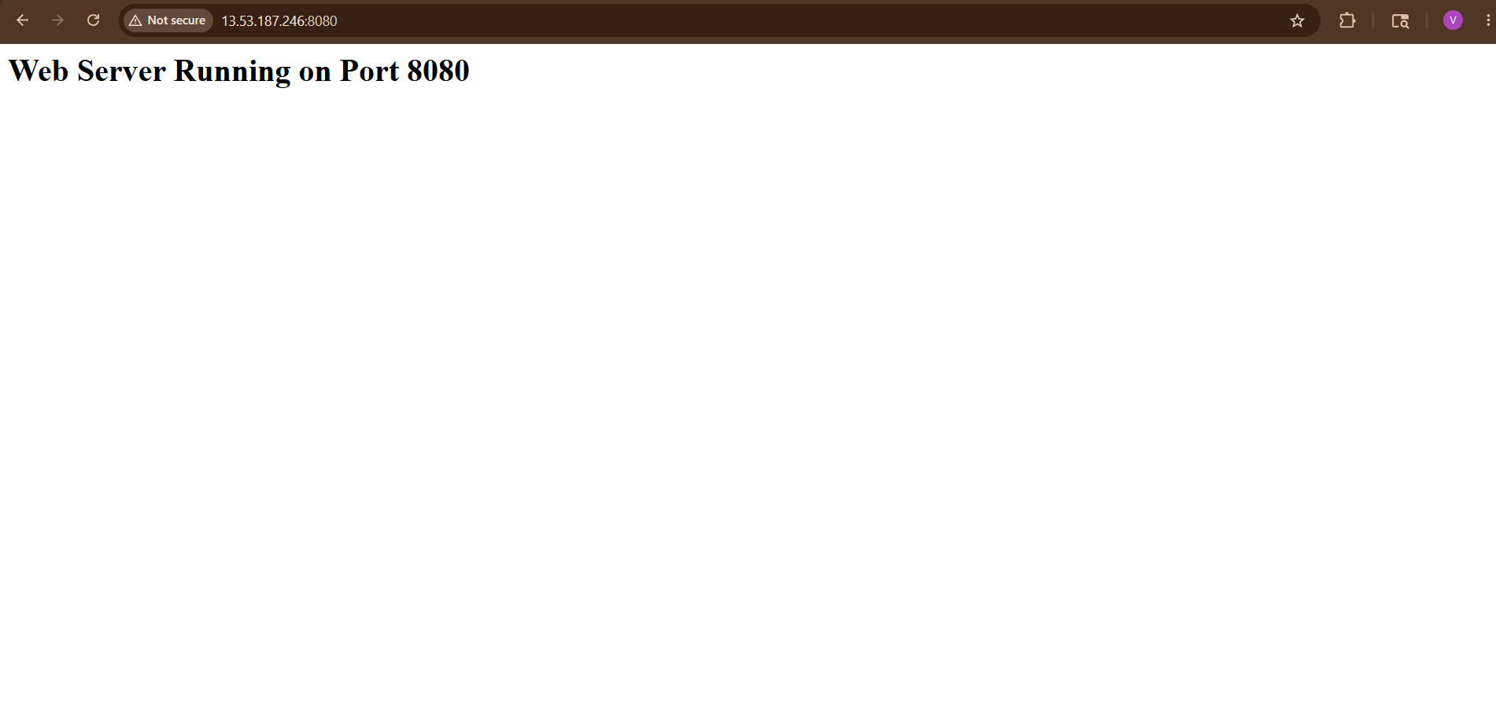

Understanding Important Parts
Security Group
Allows:
Port | Purpose
22 | SSH
8080 | Web Server

User Data
user_data
Runs automatically during EC2 startup.
Equivalent to running Linux commands manually.

Apache Installation
apt install apache2 -y
Installs Apache web server.

Change Port 80 → 8080
sed -i 's/80/8080/g'
Changes Apache listening port.

Restart Apache
systemctl restart apache2
Applies new configuration.

Common Errors
Website Not Opening
Check:
1. Security Group
Port 8080 must be open.

2. Apache Running
SSH into instance:
sudo systemctl status apache2

3. Correct URL
Must use:
http://IP:8080
NOT:
http://IP

Useful Terraform Commands
Command | Purpose
terraform init | Initialize
terraform plan | Preview
terraform apply | Create
terraform destroy | Delete
terraform output | Show outputs

Destroy Resources After Practice
terraform destroy
Type:
yes
Important to avoid AWS billing.

3) Create a Docker-compose file for the project:https://github.com/betawins/cricbuzz-docker-hello-world.gitand point it to port 8000.

Step 1: Clone the Repository
Open terminal and run:
git clone https://github.com/betawins/cricbuzz-docker-hello-world.git
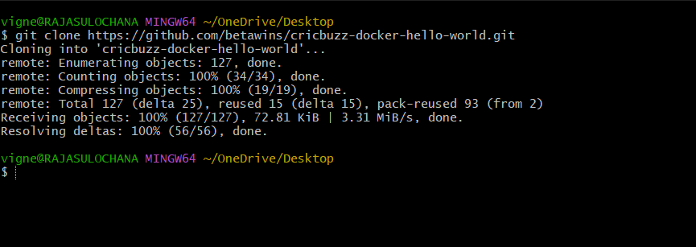

Move into the project directory:
cd cricbuzz-docker-hello-world
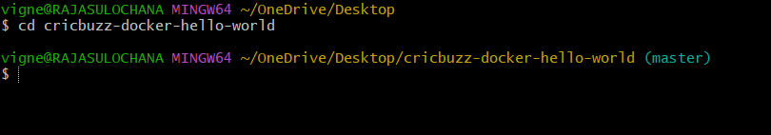

Step 2: Check Existing Files
nano Dockerfile
Replace Existing Dockerfile
# Stage 1 - Build Go App
FROM golang:1.22 AS builder
WORKDIR /app
COPY . .
RUN go mod download
RUN go build -o hello_world .
# Stage 2 - Minimal Runtime Image
FROM ubuntu:22.04
WORKDIR /
COPY --from=builder /app/hello_world .
EXPOSE 8080
CMD ["./hello_world"]
Run:
ls
You may see files like:
Dockerfile
package.json
server.js
That means the application already has a Dockerfile.
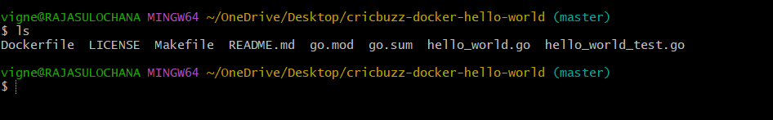

Step 3: Create docker-compose.yml File
Create the file:
touch docker-compose.yml
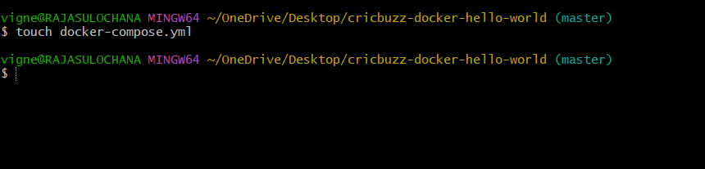
Open it:
vi docker-compose.yml
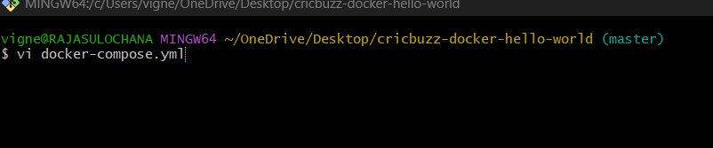
OR
nano docker-compose.yml

Step 4: Add Docker Compose Configuration
Paste this:
services:
cricbuzz-app:
build: .
container_name: cricbuzz-container
ports:
- "8000:8000"
restart: always
Save the file.
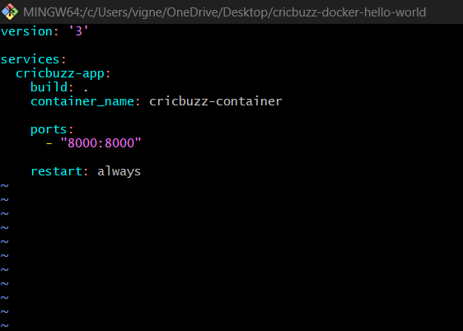

Step 5: Build and Start Containers
Run:
docker-compose up --build
OR for latest Docker Compose:
docker compose up –build
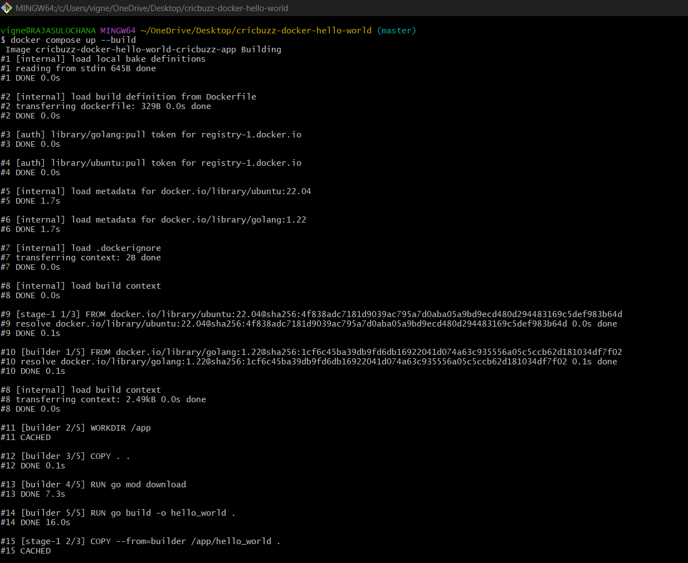
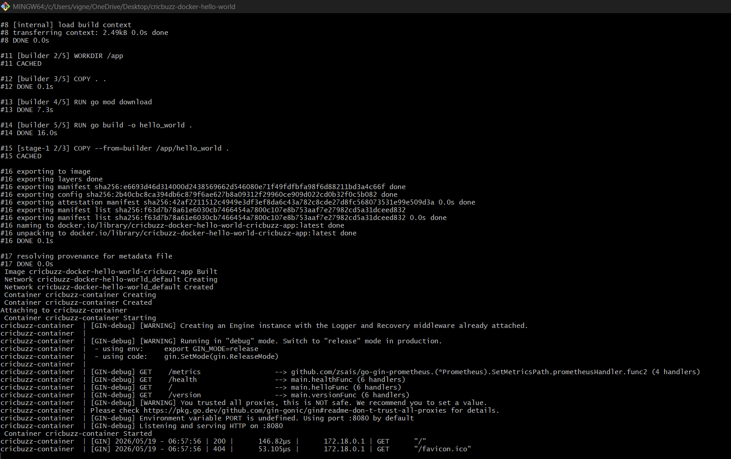

Step 6: Verify Running Containers
Check containers:
docker ps
You should see:
cricbuzz-container
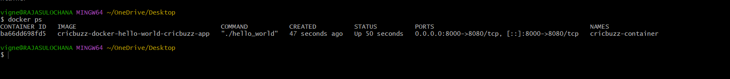
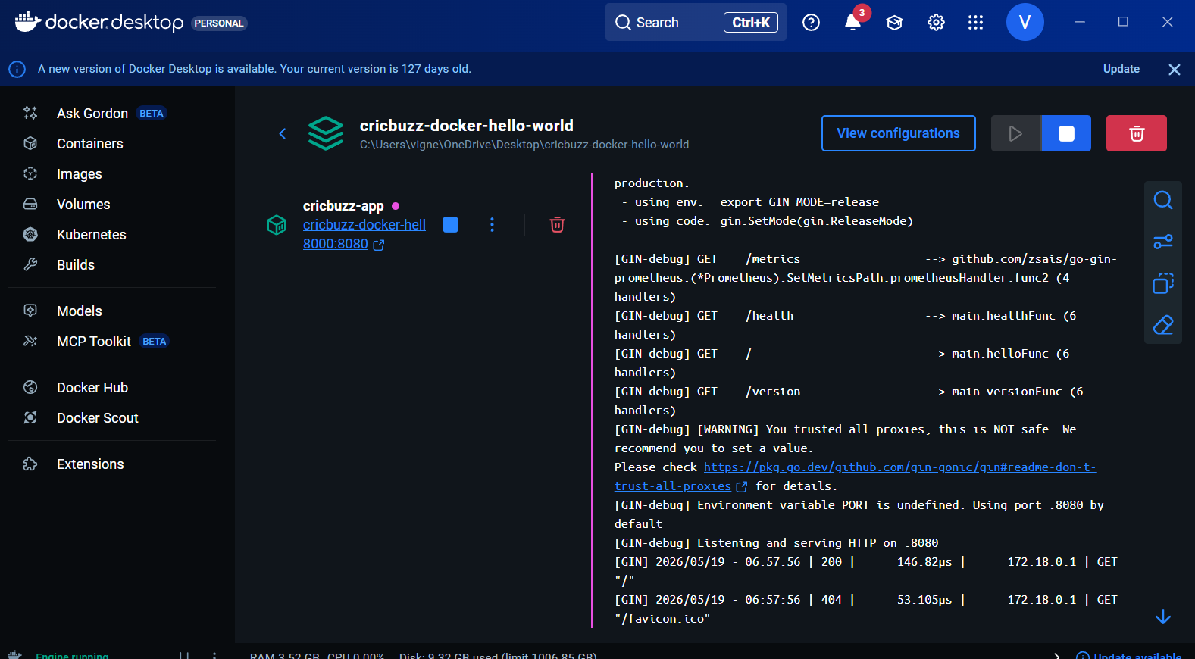

Step 7: Access Application
Open browser:
http://localhost:8000

You should see the Cricbuzz Hello World application running
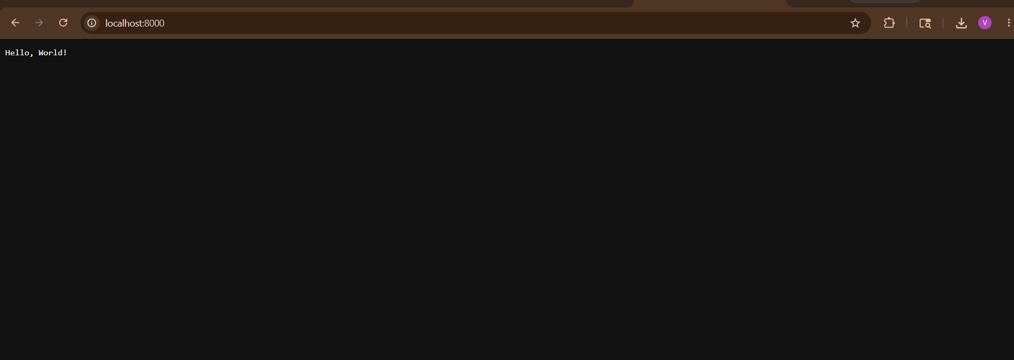

Step 8: Run in Background (Optional)
docker compose up -d

Step 9: Stop the Container
docker compose down
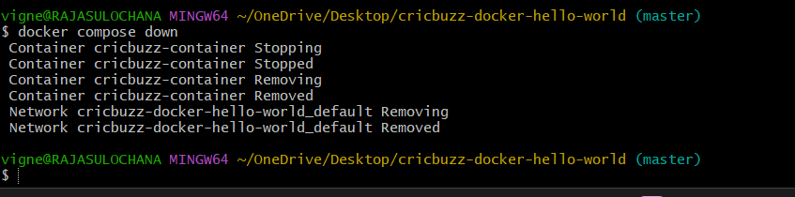

Complete Folder Structure
cricbuzz-docker-hello-world/
│
├── Dockerfile
├── docker-compose.yml
├── package.json
├── server.js

Explanation of docker-compose.yml
version: '3'
- Docker Compose version

services:
- Defines containers/services

cricbuzz-app:
- Service name

build: .
- Build image using current directory Dockerfile

container_name: cricbuzz-container
- Custom container name

ports:
- "8000:8000"

Meaning:
HOST_PORT : CONTAINER_PORT
- Left side → Local machine port
- Right side → Container application port

restart: always
- Automatically restart container if stopped/crashed

4) Make the web server point to the above service so that 8080 returns the response from the Docker service.
Configure Web Server Reverse Proxy to Docker Service (Port 8080)
Goal:
Browser → Port 8080 → Web Server → Docker Container
We will use:
- Nginx as reverse proxy
- Docker app running on port 8000
- Nginx listening on port 8080

Architecture
User Browser
↓
localhost:8080
↓
Nginx Web Server
↓
Docker Container
↓
localhost:8000

Step 1: Verify Docker Container Running
Run:
docker ps
You should see:
0.0.0.0:8000->8080/tcp
or similar.

Step 2: Install Nginx
If using Ubuntu/Linux:
sudo apt update
sudo apt install nginx -y
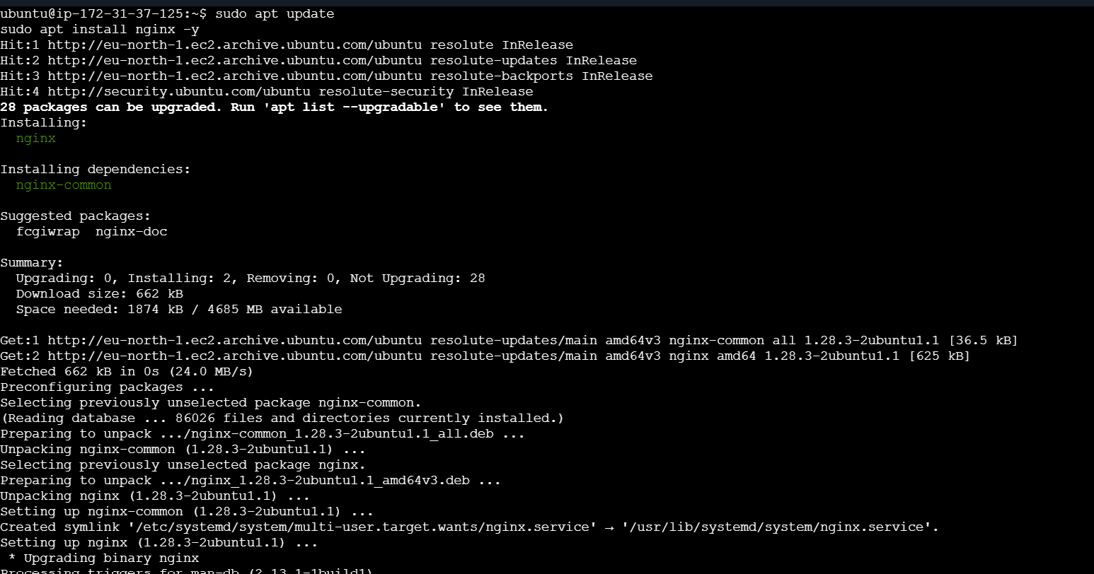
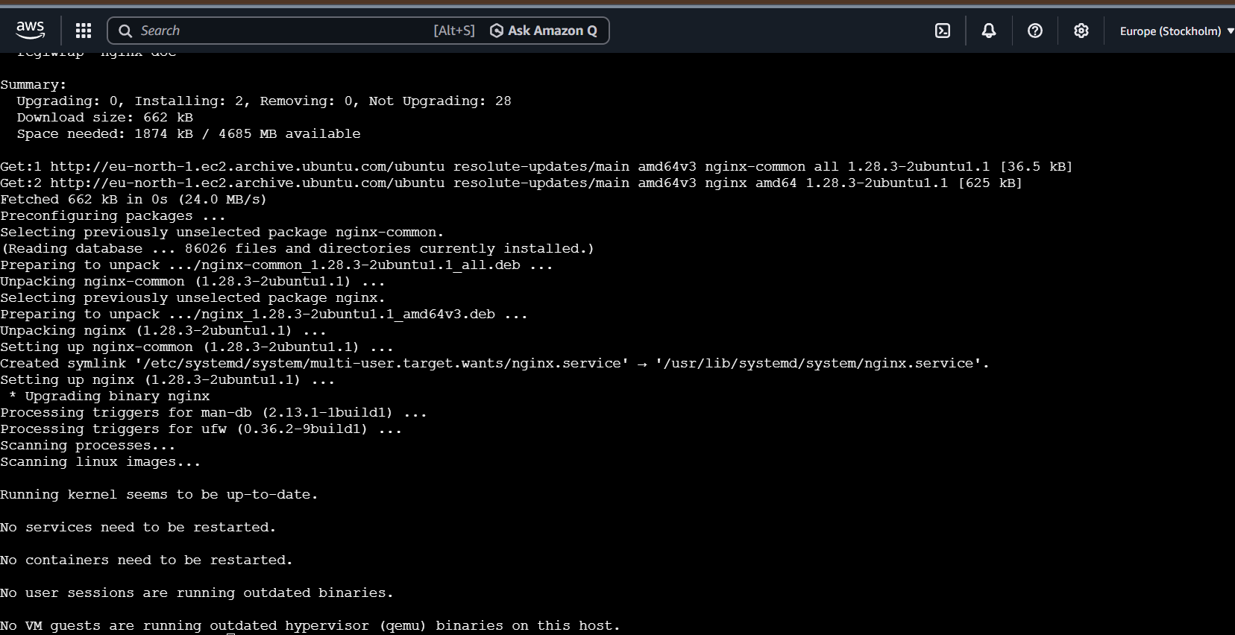

Step 3: Start Nginx
sudo systemctl start nginx
Enable auto-start:
sudo systemctl enable nginx
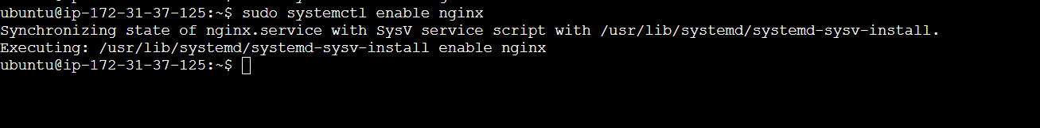
Check status:
sudo systemctl status nginx
Expected:
active (running)
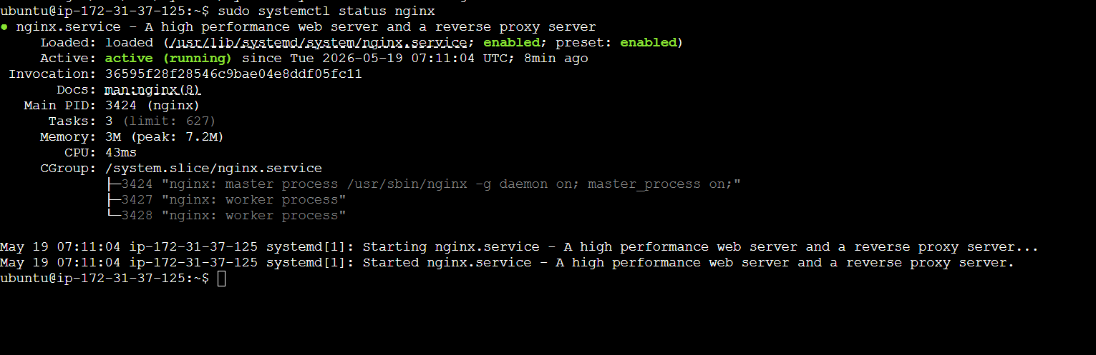

Step 4: Configure Reverse Proxy
Open Nginx config:
sudo nano /etc/nginx/sites-available/default
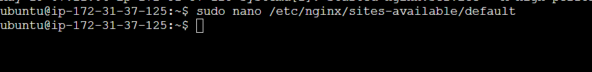

Step 5: Replace Configuration
Delete everything inside file.
Paste this:
server {
listen 8080;
location / {
proxy_pass http://localhost:8000;
proxy_http_version 1.1;
proxy_set_header Upgrade $http_upgrade;
proxy_set_header Connection 'upgrade';
proxy_set_header Host $host;
proxy_cache_bypass $http_upgrade;
}
}
Save:
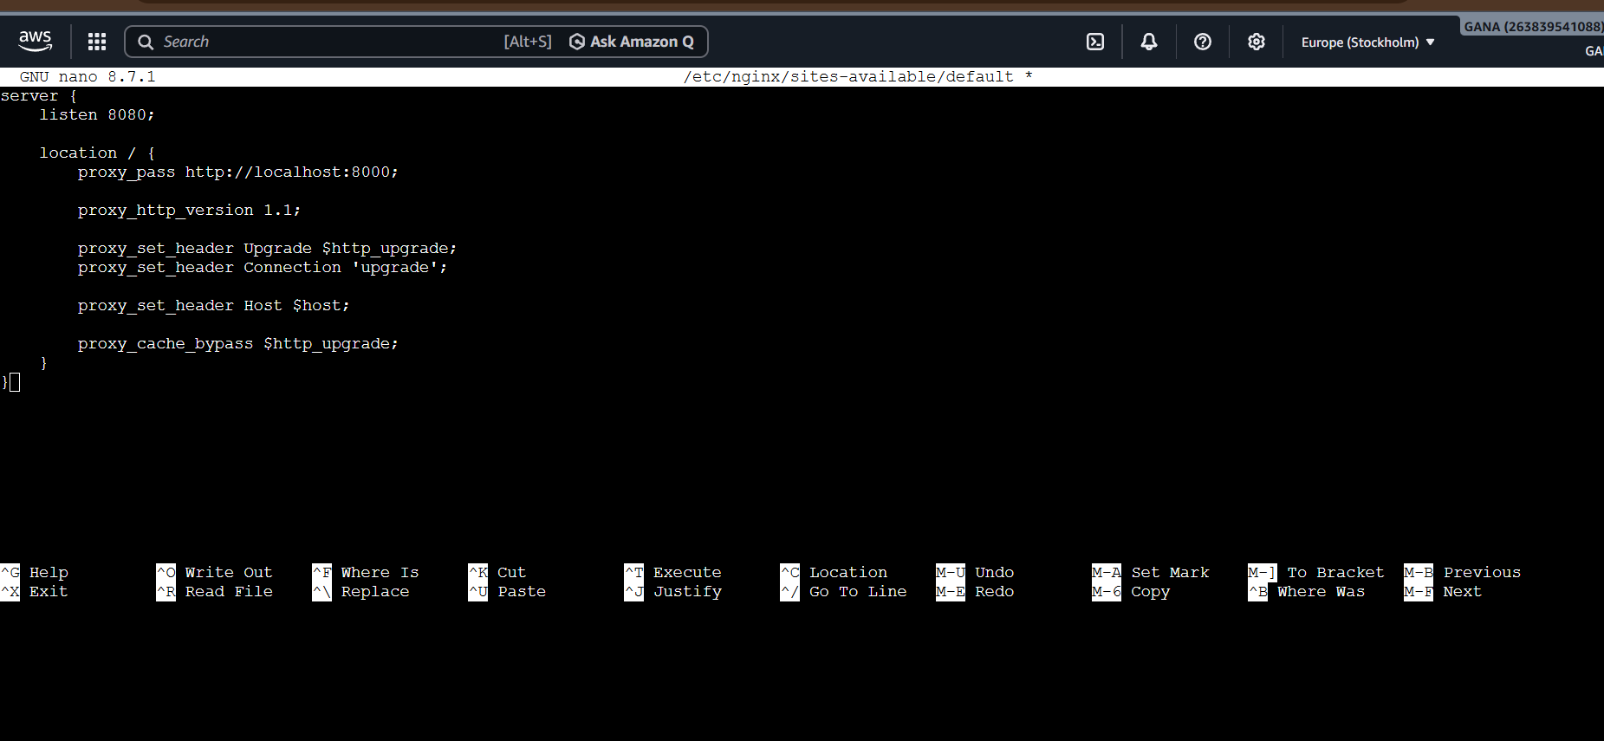
CTRL + O
ENTER
CTRL + X

Understanding Configuration
Listen on Port 8080
listen 8080;
Nginx accepts requests on:
localhost:8080

Proxy Requests
proxy_pass http://localhost:8000;
Forwards requests to Docker container.

Step 6: Test Nginx Configuration
Run:
sudo nginx -t
Expected:
syntax is ok
test is successful
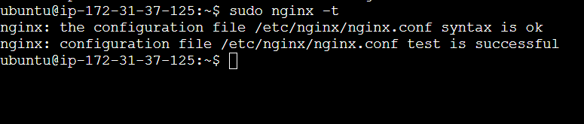

Step 7: Restart Nginx
sudo systemctl restart nginx
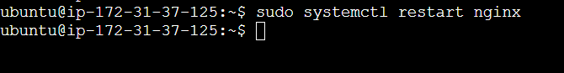

Step 8: Open Browser
Now access:
http://13.53.187.246:8080/

You should see:
Hello World
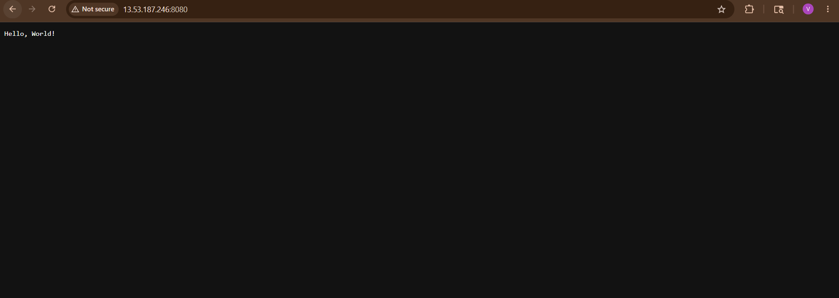

Real Flow
Browser Request
↓
Nginx :8080
↓
Proxy Pass
↓
Docker App :8000
↓
Response Returned

Important DevOps Concept
This setup is called:
Reverse Proxy
Nginx sits in front of applications and forwards traffic.
Used for:
- Load balancing
- SSL termination
- Security
- Routing
- High availability

Verify Listening Ports
Run:
sudo netstat -tulnp | grep 8080
or
ss -tulnp | grep 8080
Expected:
nginx listening on 8080

Common Errors
1. 502 Bad Gateway
Cause:
- Docker container not running
Fix:
docker ps

2. Port Already Used
Check:
sudo lsof -i :8080

3. Nginx Not Restarting
Check logs:
sudo journalctl -u nginx

5) Configure to Save the Logs in the location /var/log/cb.log

Configure Logs to Save in /var/log/cb.log — Step by Step
Goal:
Docker App Logs → /var/log/cb.log
We will configure Docker logging using:
docker logs + redirection

Step 1: Go to Project Directory
SSH into EC2 and go inside project:
cd ~/cricbuzz-docker-hello-world
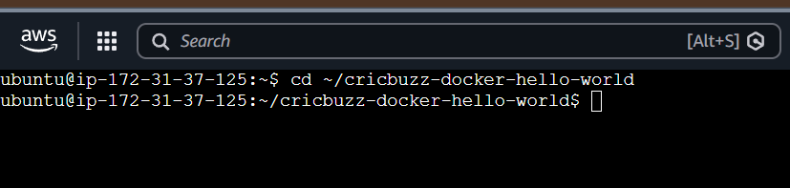

Step 2: Stop Existing Container
Run:
sudo docker compose down
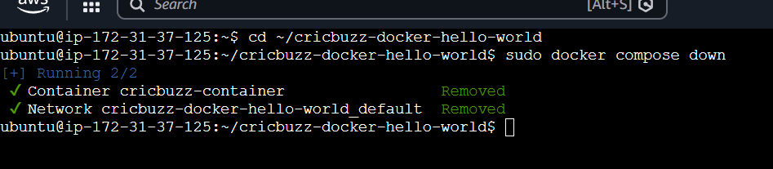

Step 3: Create Log File
Run:
sudo touch /var/log/cb.log
Give permissions:
sudo chmod 666 /var/log/cb.log
Verify:
ls -l /var/log/cb.log
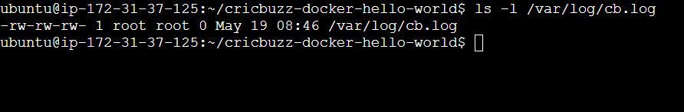

Step 4: Start Container Again
Run:
sudo docker compose up --build -d
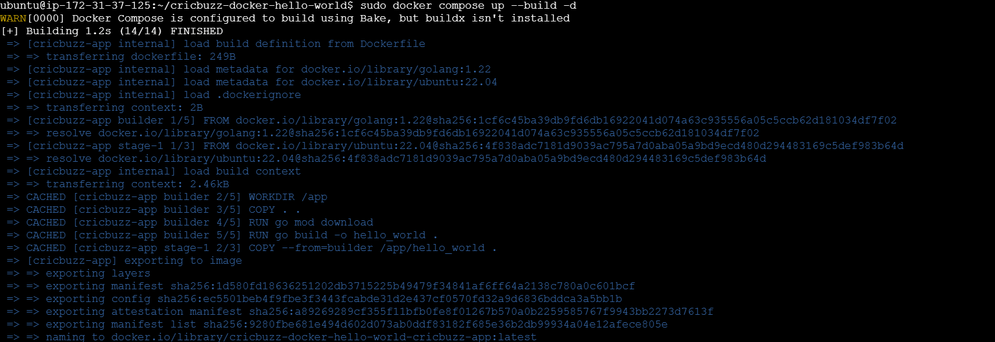
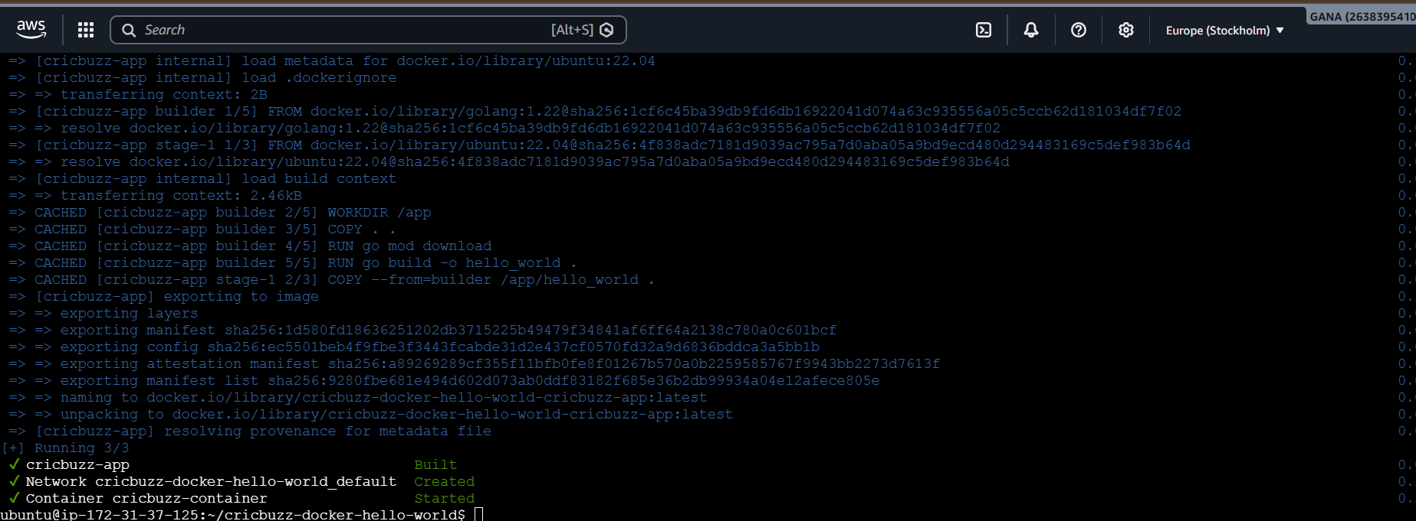

Step 5: Get Container Name
Run:
sudo docker ps
Expected:
cricbuzz-container
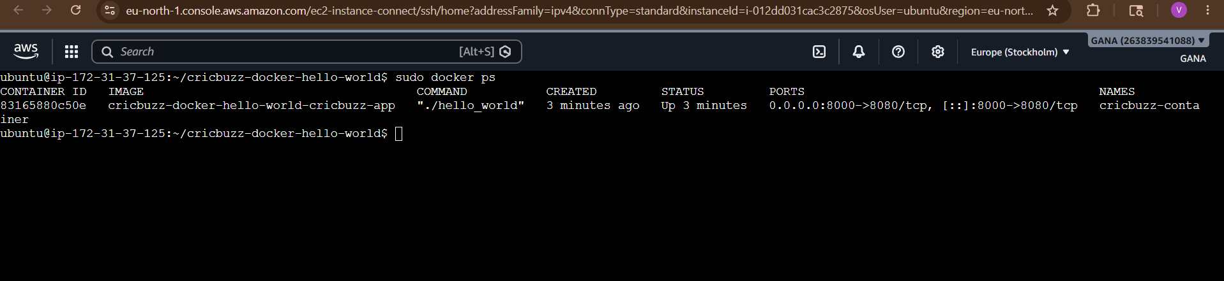

Step 6: Redirect Logs to File
Run:
sudo docker logs -f cricbuzz-container >> /var/log/cb.log 2>&1 &

Understanding This Command
Follow Logs
docker logs -f
Continuously streams logs.
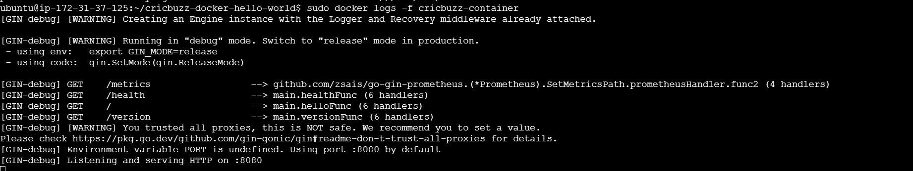

Append to File
>> /var/log/cb.log
Saves logs into file.
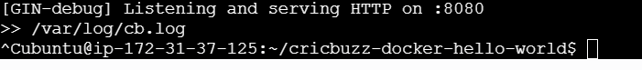

Save Errors Also
2>&1

Redirects:
- stdout
- stderr
both into same file.

Run in Background
&
Keeps process running in background.

Step 7: Verify Logs
Run:
cat /var/log/cb.log
You should see:
GIN-debug
Listening on :8080
GET /
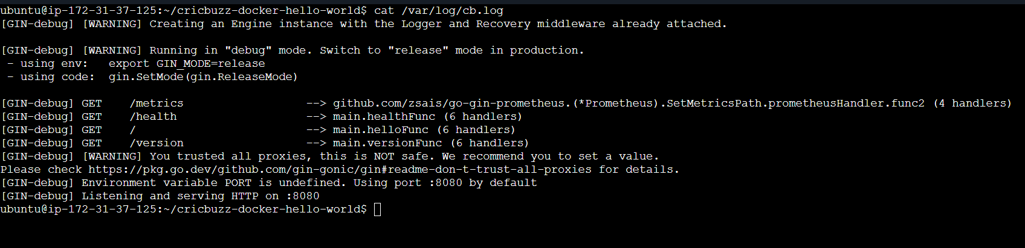

Step 8: Live Log Monitoring
Run:
tail -f /var/log/cb.log
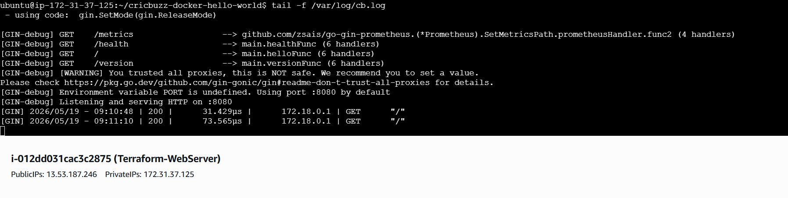

Now open app in browser:
http://EC2-PUBLIC-IP:8080
http://13.53.187.246:8080/
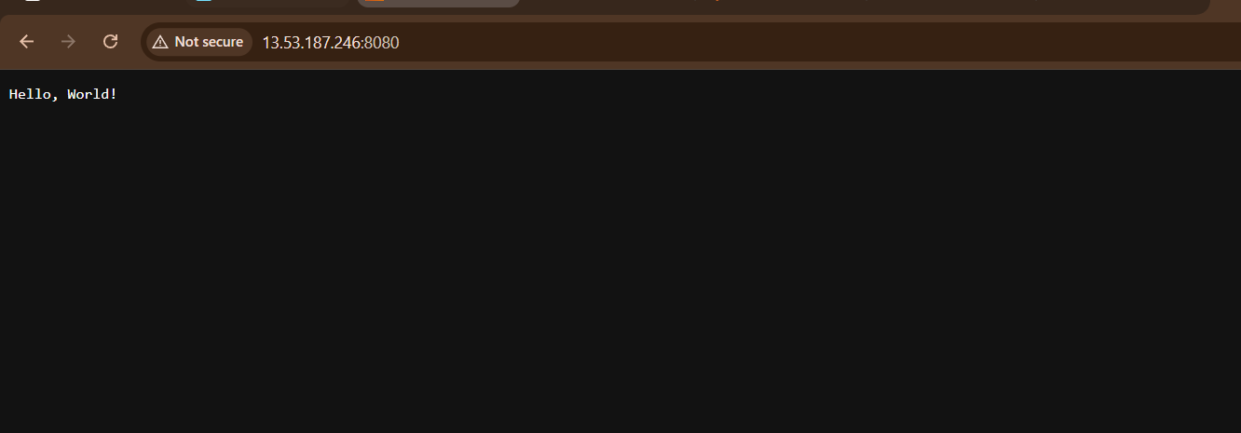
You will see live requests appearing.

Example Output
[GIN-debug] Listening on :8080
[GIN] 2026/05/19 - GET /

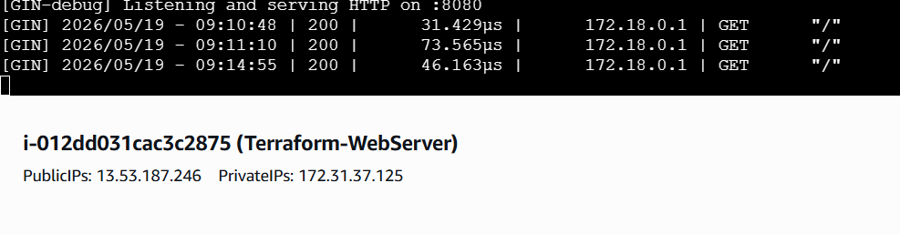

Final Architecture
Browser
↓
Nginx :8080
↓
Docker App :8000
↓
Container :8080
↓
Logs → /var/log/cb.log

6) Write the Log rotate configuration for the above file

Configure Logrotate for /var/log/cb.log
Goal:
/var/log/cb.log
should:
- rotate automatically
- prevent huge log files
- keep old backups
- compress old logs

What is Logrotate?
logrotate automatically:
✅ rotates logs
✅ compresses logs
✅ deletes old logs
✅ prevents disk full issues

Step 1: Verify Logrotate Installed
Run:
logrotate –version
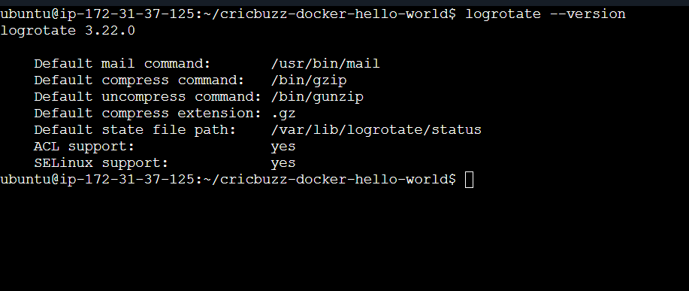
If not installed:
sudo apt install logrotate -y

Step 2: Create Logrotate Configuration File
Create new config:
sudo nano /etc/logrotate.d/cb

Step 3: Add Configuration
Paste this:
/var/log/cb.log {
daily
rotate 7
compress
delaycompress
missingok
notifempty
copytruncate
su root root
}
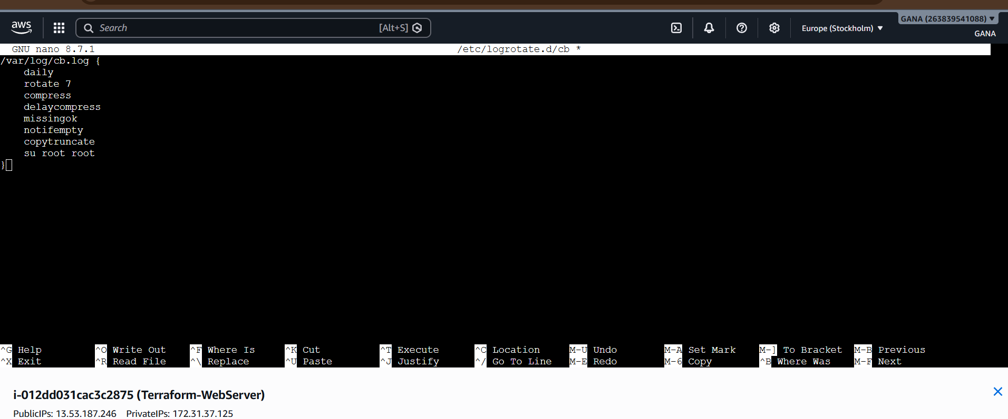
Save:
CTRL + O
ENTER
CTRL + X

Understanding Each Option
Option | Meaning
daily | Rotate every day
missingok | Ignore if file missing
rotate 7 | Keep 7 old log files
compress | Compress old logs
delaycompress | Compress from next rotation
notifempty | Skip empty logs
copytruncate | Safely rotate active logs

Important Option
copytruncate
Very important for Docker/live applications.
Without it:
- app may continue writing to deleted file
With it:
- log file safely truncated
- app continues logging normally

Step 4: Test Configuration
Run:
sudo logrotate -d /etc/logrotate.d/cb
This performs:
- dry run
- no actual changes
Expected:
considering log /var/log/cb.log
No errors = good ✅
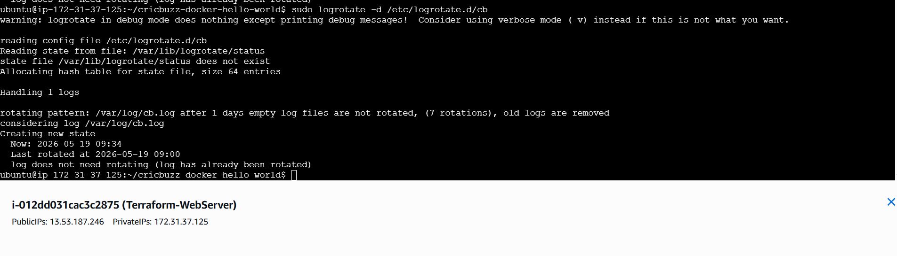

Step 5: Force Manual Rotation (Testing)
Run:
sudo logrotate -f /etc/logrotate.d/cb

Step 6: Verify Rotated Logs
Run:
ls -l /var/log/cb*
Expected:
/var/log/cb.log
/var/log/cb.log.1
/var/log/cb.log.2.gz
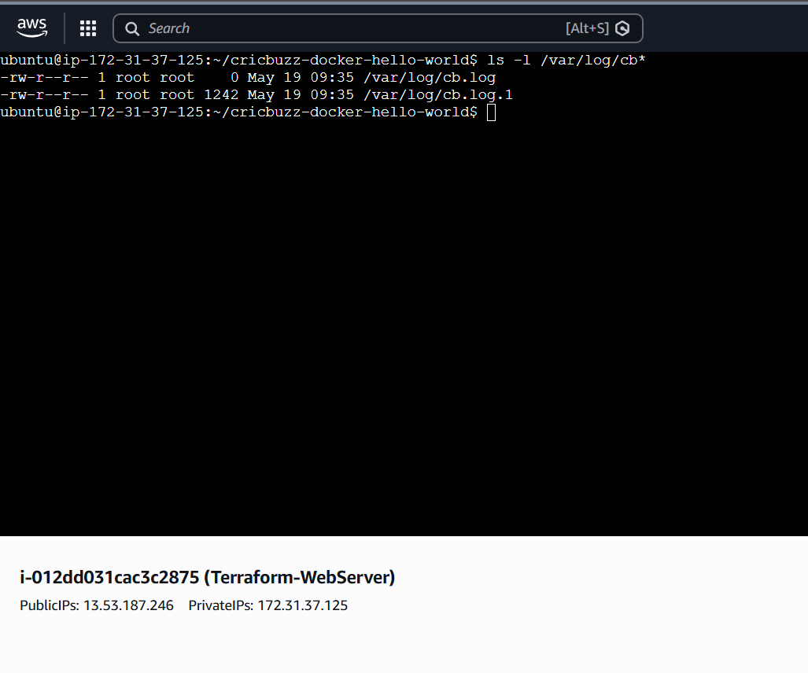

Step 7: Verify Current Log Still Works
Run:
tail -f /var/log/cb.log
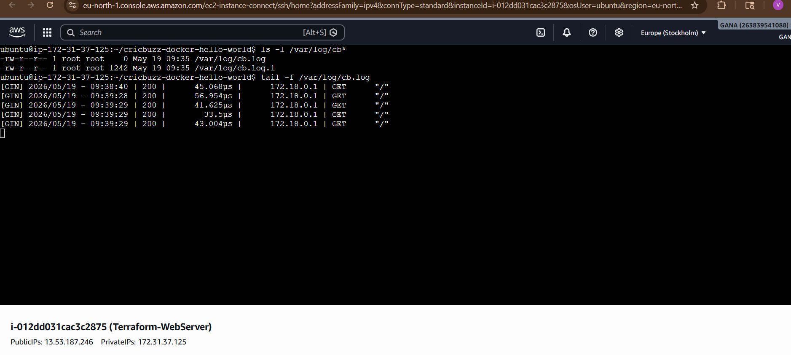
Refresh app:
http://13.53.187.246:8080
Logs should continue appearing.
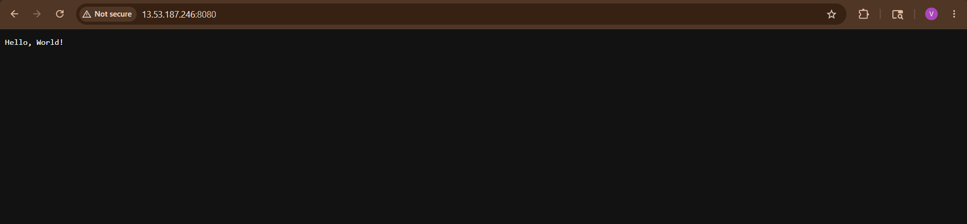

Real Production Behavior
After several days:
/var/log/cb.log
/var/log/cb.log.1
/var/log/cb.log.2.gz
/var/log/cb.log.3.gz
Older files become compressed.

How Automatic Rotation Works
Ubuntu automatically runs:
cron + logrotate
daily from:
/etc/cron.daily/logrotate
No manual work needed after configuration.

Check Cron Job
Run:
cat /etc/cron.daily/logrotate
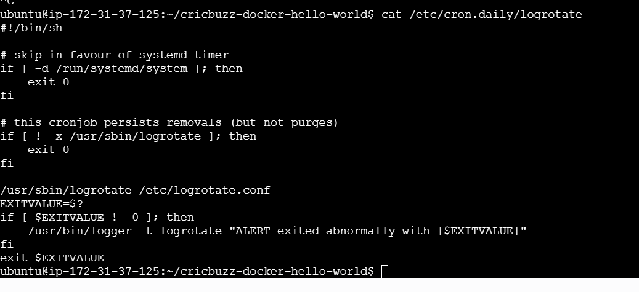

Final Architecture
Docker Logs
↓
/var/log/cb.log
↓
Logrotate
↓
Compressed Rotated Logs

